Eli Laird

CS 7350

Homework 2

**Problem 1:**

* **Asymptotic Bounds:**
* **Support:** From the data in the table, we can conclude that the algorithm is bounded by *.* We see that the function is bounded by *p* when we increase *p* by a factor of 10 and keep *m* and *n* the same, *t* increase by a factor of 10. When we increase *n* by a factor of 2 and keep *p* and *m* the same, *t* increases by a factor of 2. When we increase *p* by a factor of 10 AND increase *n* by a factor of 2, *t* increases by a factor of 10 * 2, or in other words *pn*. Whenever *m* is increased, this reduces the amount of collisions when drawing from the distribution, thus decreasing the value of *t*. This relation of *m* to *t* is independent from *pm* so the final bounds are.

|  |  |  |  |
| --- | --- | --- | --- |
| **Unique Iterations with Uniform Distribution** | | | |
| p | n | m | t (nanoseconds) |
| 100 | 5 | 20 | 85017 |
| 100 | 5 | 100 | 67829 |
| 100 | 5 | 500 | 58515 |
| 100 | 10 | 20 | 208219 |
| 100 | 10 | 100 | 153057 |
| 100 | 10 | 500 | 125981 |
| 100 | 15 | 20 | 448288 |
| 100 | 15 | 100 | 257391 |
| 100 | 15 | 500 | 206341 |
| 1000 | 5 | 20 | 819032 |
| 1000 | 5 | 100 | 686410 |
| 1000 | 5 | 500 | 587768 |
| 1000 | 10 | 20 | 2053418 |
| 1000 | 10 | 100 | 1456296 |
| 1000 | 10 | 500 | 1214312 |
| 1000 | 15 | 20 | 4108572 |
| 1000 | 15 | 100 | 2463805 |
| 1000 | 15 | 500 | 1972694 |
| 10000 | 5 | 20 | 7876627 |
| 10000 | 5 | 100 | 6490328 |
| 10000 | 5 | 500 | 5724835 |
| 10000 | 10 | 20 | 20865959 |
| 10000 | 10 | 100 | 14819085 |
| 10000 | 10 | 500 | 12174799 |
| 10000 | 15 | 20 | 40157165 |
| 10000 | 15 | 100 | 22674070 |
| 10000 | 15 | 500 | 15654036 |
|  |  |  |  |

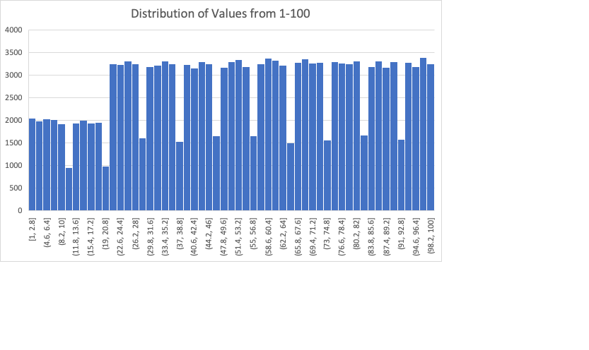

**Code:**

**bool** isUnique(**int** j, **int** arr[], **int** start, **int** end){  
 **for**(**int** i = start; i<=end; i++)  
 **if**(arr[i] == j)  
 **return false**;  
 **return true**;  
}  
  
**long long** problem1(**long** n, **long** m, **int** p, std::default_random_engine generator, **bool** printDist = **false**){  
 **using namespace** std::chrono;  
  
 **int** arr[p * n];  
 **int** iter = 0;  
 std::uniform_int_distribution<**long int**> dist(1,m);  
  
 *//measure starting time* high_resolution_clock::time_point start = high_resolution_clock::now();  
  
 *//loop p iterations* **for**(**int** i = 0; i < p; i++){  
 **int** uniqueNums = 0;  
 **int** setIter = iter;  
  
 *//loop until n unique numbers are generated* **while**(uniqueNums < n){  
 **int** x = dist(generator);  
  
 **if**(isUnique(x, arr, setIter, setIter+n-1)){  
 arr[iter++] = x;  
 uniqueNums++;  
 }  
 }  
 }  
  
 *//measure total time* high_resolution_clock::time_point end = high_resolution_clock::now();  
 **auto** total_time = duration_cast<nanoseconds>(end - start).count();  
 std::cout << **"p: "** << p << **" n: "** << n << **" m: "** << m << **" time: "** << total_time << std::endl;  
  
 **if**(printDist){  
 *//store distribution of numbers to file* std::ofstream fout(**"problem1_dist.csv"**);  
 **for**(**int** i = 0; i < n*p; i++)  
 fout << arr[i] << **",\n"**;  
 fout.close();  
 }  
  
  
 **return** total_time;  
  
}

**Problem 2:**

* **Asymptotic Bounds:**
* **Support:** From the data in the table, we can conclude that the algorithm is bounded by *.* We see that the function is bounded by *p* when we increase *p* by a factor of 10 and keep *m* and *n* the same, *t* increase by a factor of 10. When we increase *n* by a factor of 2 and keep *p* and *m* the same, *t* increases by a factor of 2. When we increase *p* by a factor of 10 and increase *n* by a factor of 2, *t* increases by a factor of 10 * 2, or in other words *pn*. Whenever *m* is increased, this reduces the amount of collisions when drawing from the distribution, thus decreasing the value of *t*. This decrease is less than in Problem 1 due to the *skewed* distribution. This relation of *m* to *t* is independent from *pm* so the final bounds are.

|  |  |  |  |
| --- | --- | --- | --- |
| **Unique Iterations for Skewed Distribution** | | | |
| p | n | m | t (nanoseconds) |
| 100 | 5 | 20 | 88378 |
| 100 | 5 | 100 | 80031 |
| 100 | 5 | 500 | 81402 |
| 100 | 10 | 20 | 309971 |
| 100 | 10 | 100 | 168864 |
| 100 | 10 | 500 | 384123 |
| 100 | 15 | 20 | 1264845 |
| 100 | 15 | 100 | 299151 |
| 100 | 15 | 500 | 291882 |
| 1000 | 5 | 20 | 886520 |
| 1000 | 5 | 100 | 765789 |
| 1000 | 5 | 500 | 878860 |
| 1000 | 10 | 20 | 2928734 |
| 1000 | 10 | 100 | 1616659 |
| 1000 | 10 | 500 | 1895595 |
| 1000 | 15 | 20 | 11686244 |
| 1000 | 15 | 100 | 3463592 |
| 1000 | 15 | 500 | 2709388 |
| 10000 | 5 | 20 | 8775396 |
| 10000 | 5 | 100 | 10248381 |
| 10000 | 5 | 500 | 12085335 |
| 10000 | 10 | 20 | 35060850 |
| 10000 | 10 | 100 | 20666251 |
| 10000 | 10 | 500 | 12446172 |
| 10000 | 15 | 20 | 111452014 |
| 10000 | 15 | 100 | 25310469 |
| 10000 | 15 | 500 | 20004239 |

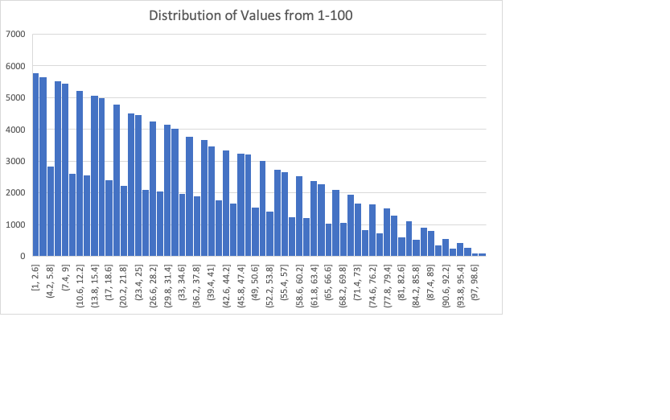

**Code:**

std::vector<**int**>* skewed_distribution(**int** m, std::default_random_engine generator){  
 std::vector<**int**> *dist = **new** std::vector<**int**>();  
 **int** val = 1;  
 *//create skewed distribution by adding numbers with skewed num of occurences* **for**(**int** i = m; i > 0; i--){  
 **for**(**int** j = 0; j < i; j++)  
 dist->push_back(val);  
 val++;  
 }  
  
 *//shuffle distribution* std::shuffle(dist->begin(),dist->end(), generator);  
 **return** dist;  
}  
  
**long long** problem2(**long** n, **long** m, **int** p, std::default_random_engine generator, **bool** printDist = **false**){  
 **using namespace** std::chrono;  
  
 **int** arr[p * n];  
 **int** iter = 0;  
 std::vector<**int**>* dist_skewed = skewed_distribution(m, generator); *//create skewed distribution* std::uniform_int_distribution<**long int**> rand(0,dist_skewed->size()-1); *//rand # generator for skewed dist selection  
  
 //measure starting time* high_resolution_clock::time_point start = high_resolution_clock::now();  
  
 *//loop p iterations* **for**(**int** i = 0; i < p; i++){  
 **int** uniqueNums = 0;  
 **int** setIter = iter;  
  
 *//loop until n unique numbers are generated* **while**(uniqueNums < n){  
 **int** x = dist_skewed->at(rand(generator)); *//select a random # from skewed distribution* **if**(isUnique(x, arr, setIter, setIter+n-1)){  
 arr[iter++] = x;  
 uniqueNums++;  
 }  
 }  
 }  
  
 *//measure total time* high_resolution_clock::time_point end = high_resolution_clock::now();  
 **auto** total_time = duration_cast<nanoseconds>(end - start).count();  
 std::cout << **"p: "** << p << **" n: "** << n << **" m: "** << m << **" time: "** << total_time << std::endl;  
  
 **if**(printDist){  
 *//store distribution of numbers to file* std::ofstream fout(**"problem2_dist.csv"**);  
 **for**(**int** i = 0; i < n*p; i++)  
 fout << arr[i] << **",\n"**;  
 fout.close();  
 }  
  
 **return** total_time;  
}

**Problem 3:**

* **Asymptotic Bounds:**
* **Support:** From the table, we can conclude that this function is bounded by . We see this when we increase *n* by a factor of 10, *t* increases by a factor of 100, or .

|  |  |
| --- | --- |
| **Sorting N Numbers with Bubble Sort** | |
| n | t (nanoseconds) |
| 10 | 1715 |
| 100 | 29587 |
| 1000 | 1977750 |
| 10000 | 322396507 |
| 100000 | 2.4608E+10 |

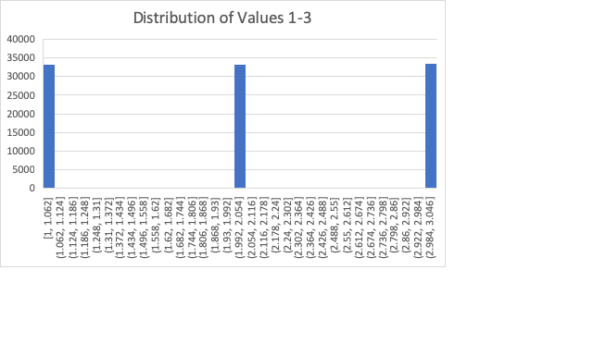

**Code:**

*//Adapted from https://www.geeksforgeeks.org/bubble-sort/***void** swap(**int** *xp, **int** *yp)  
{  
 **int** temp = *xp;  
 *xp = *yp;  
 *yp = temp;  
}  
  
*//Adapted from https://www.geeksforgeeks.org/bubble-sort/***void** bubbleSort(**int** arr[], **int** n)  
{  
 **int** i, j;  
 **for** (i = 0; i < n-1; i++)  
  
 *// Last i elements are already in place* **for** (j = 0; j < n-i-1; j++)  
 **if** (arr[j] > arr[j+1])  
 swap(&arr[j], &arr[j+1]);  
}  
  
**long long** problem3(**long** n, std::default_random_engine generator, **bool** printDist = **false**){  
 **using namespace** std::chrono;  
  
 **int** arr[n];  
 std::uniform_int_distribution<**long int**> dist(1,3);  
  
 *//measure starting time* high_resolution_clock::time_point start = high_resolution_clock::now();  
  
 *//insert n random numbers between 1 & 3* **for**(**int** i = 0; i < n; i ++)  
 arr[i] = dist(generator);  
  
 *//sort array using bubble sort* bubbleSort(arr, n);  
  
 *//measure total time* high_resolution_clock::time_point end = high_resolution_clock::now();  
 **auto** total_time = duration_cast<nanoseconds>(end - start).count();  
 std::cout << **"n: "** << n << **" time: "** << total_time << std::endl;  
  
 **if**(printDist){  
 *//store distribution of numbers to file* std::ofstream fout(**"problem3_dist.csv"**);  
 **for**(**int** i = 0; i < n; i++)  
 fout << arr[i] << **",\n"**;  
 fout.close();  
 }  
  
  
 **return** total_time;  
  
}

**Problem 4:**

* **Asymptotic Bounds:**
* **Support:** We can see from the table that the function is bounded by *n* whenever we increase *n* by a factor of 10, the value of *t* will also increase by a factor of 10. The *logn* comes from the functionality of merge sort. Merge sort continuously divides the array into two until the split array is of size 1. Once completely divided, the divided arrays are combined in sorted order. This division explains the *logn* portion of the asymptotic bounds, thus concluding with .

|  |  |
| --- | --- |
| **Sorting N Numbers with Merge Sort** | |
| n | t |
| 10 | 2027 |
| 100 | 18369 |
| 1000 | 179661 |
| 10000 | 2709500 |
| 100000 | 18397437 |



**Code:**

*//Adapted from https://www.geeksforgeeks.org/merge-sort/***void** merge(**int** arr[], **int** l, **int** m, **int** r)  
{  
 **int** i, j, k;  
 **int** n1 = m - l + 1;  
 **int** n2 = r - m;  
  
 */* create temp arrays */* **int** L[n1], R[n2];  
  
 */* Copy data to temp arrays L[] and R[] */* **for** (i = 0; i < n1; i++)  
 L[i] = arr[l + i];  
 **for** (j = 0; j < n2; j++)  
 R[j] = arr[m + 1+ j];  
  
 */* Merge the temp arrays back into arr[l..r]*/* i = 0; *// Initial index of first subarray* j = 0; *// Initial index of second subarray* k = l; *// Initial index of merged subarray* **while** (i < n1 && j < n2)  
 {  
 **if** (L[i] <= R[j])  
 {  
 arr[k] = L[i];  
 i++;  
 }  
 **else** {  
 arr[k] = R[j];  
 j++;  
 }  
 k++;  
 }  
  
 */* Copy the remaining elements of L[], if there  
 are any */* **while** (i < n1)  
 {  
 arr[k] = L[i];  
 i++;  
 k++;  
 }  
  
 */* Copy the remaining elements of R[], if there  
 are any */* **while** (j < n2)  
 {  
 arr[k] = R[j];  
 j++;  
 k++;  
 }  
}

*//Adapted from https://www.geeksforgeeks.org/merge-sort/***void** mergeSort(**int** arr[], **int** l, **int** r)  
{  
 **if** (l < r)  
 {  
 *// Same as (l+r)/2, but avoids overflow for  
 // large l and h* **int** m = l+(r-l)/2;  
  
 *// Sort first and second halves* mergeSort(arr, l, m);  
 mergeSort(arr, m+1, r);  
  
 merge(arr, l, m, r);  
 }  
}  
  
**long long** problem4(**int** n, std::default_random_engine generator, **bool** printDist){  
 **using namespace** std::chrono;  
  
 **int** arr[n];  
 std::uniform_int_distribution<**long int**> dist(1,3);  
  
 *//measure starting time* high_resolution_clock::time_point start = high_resolution_clock::now();  
  
 *//insert n random numbers between 1 & 3* **for**(**int** i = 0; i < n; i ++)  
 arr[i] = dist(generator);  
  
 *//sort array using bubble sort* mergeSort(arr, 0, n-1);  
  
 *//measure total time* high_resolution_clock::time_point end = high_resolution_clock::now();  
 **auto** total_time = duration_cast<nanoseconds>(end - start).count();  
 std::cout << **"n: "** << n << **" time: "** << total_time << std::endl;  
  
 **if**(printDist){  
 *//store distribution of numbers to file* std::ofstream fout(**"problem3_dist.csv"**);  
 **for**(**int** i = 0; i < n; i++)  
 fout << arr[i] << **",\n"**;  
 fout.close();  
 }  
  
  
 **return** total_time;  
}

**Main.cpp**

**int** main() {  
  
 *//For each value, total numbers generated is p x n* **int** p[] = {100, 1000, 10000};  
 **int** n[] = {5, 10, 15};  
 **int** m[] = {20, 100, 500};  
  
 std::random_device rd;  
 std::default_random_engine generator(rd());  
  
 **long** time_1;  
 **long** time_2;  
 **long** time_3;  
 **long** time_4;  
  
 std::ofstream fout(**"problem1_data.csv"**);  
 std::ofstream fout2(**"problem2_data.csv"**);  
  
 *//Run values for problems 1-2* fout << **"p,n,m,t\n"**;  
 fout2 << **"p,n,m,t\n"**;  
 **bool** printDist = **false**;  
 **int** iter = 0;  
 **for**(**int** p_i : p){  
 **for**(**int** n_i : n){  
 **for**(**int** m_i : m){  
 **if**(m_i == 100 && n_i == 15 && p_i == 10000)  
 printDist = **true**;  
 time_1 = problem1(n_i,m_i,p_i, generator, printDist);  
 time_2 = problem2(n_i,m_i,p_i, generator, printDist);  
  
 fout << p_i << **","** << n_i << **","** << m_i << **","** << time_1 << **"\n"**;  
 fout2 << p_i << **","** << n_i << **","** << m_i << **","** << time_2 << **"\n"**;  
  
 printDist = **false**;  
 }  
 }  
 }

*Continued on next page*

fout.close();  
 fout2.close();  
  
 std::ofstream fout3(**"problem3_data.csv"**);  
 std::ofstream fout4(**"problem4_data.csv"**);  
  
 fout3 << **"n,t\n"**;  
 fout4 << **"n,t\n"**;  
  
 *//run values for problems 3-4* **int** n2[] = {10, 100, 1000, 10000, 100000};  
  
 printDist = **false**;  
 **for**(**int** i = 0; i < 5; i++){  
 **if**(i == 4)  
 printDist = **true**;  
  
 time_3 = problem3(n2[i], generator, printDist);  
 time_4 = problem4(n2[i], generator, printDist);  
  
 fout3 << n2[i] << **","** << time_3 << **"\n"**;  
 fout4 << n2[i] << **","** << time_4 << **"\n"**;  
 }  
  
 fout3.close();  
 fout4.close();  
  
  
  
 **return** 0;